ABSTRACT

In modern web application security, the management of sensitive resource access is a critical challenge. Traditional systems often rely on static URLs for operations such as password resets, document sharing, and user invitations, which remain active indefinitely and expose applications to replay attacks, credential sharing, and unauthorized access. This inherent vulnerability demands a more secure, automated, and ephemeral approach to link management.
This project presents the design and implementation of a Secure One-Time Access Link API using Java and the Spring Boot framework. The system generates cryptographically secure UUID-based tokens upon request, which act as single-use proxies for underlying secured resources. Once a token is accessed via an HTTP GET request, its state is immediately and atomically mutated to invalid, preventing any subsequent access. The use of Java's ConcurrentHashMap ensures thread-safe, race-condition-free state management, guaranteeing that tokens cannot be exploited twice even under high concurrency.
Any subsequent attempt to use an already-consumed token is rejected with an HTTP 410 Gone response, effectively neutralizing link-reuse attacks. The system is stateless and lightweight, making it suitable for integration into larger distributed microservice architectures as a foundational security layer.
Beyond application logic, the project incorporates modern DevOps methodologies. The microservice is fully containerized using Docker for consistent runtime environments and is integrated into an automated CI/CD pipeline using Jenkins. This ensures that the system is not only functionally secure but also production-ready and scalable for deployment in cloud environments.
Overall, this project demonstrates a complete DevOps lifecycle including development, integration, testing, containerization, and automated deployment. It provides a practical, reusable security component that enforces the principle of least privilege, significantly reducing the attack surface for applications that deal with sensitive, time-critical user operations.

CHAPTER 1

INTRODUCTION & PROJECT OVERVIEW
1.1 Introduction
In the modern era of web application development, security and access control are fundamental concerns. Applications increasingly require mechanisms to share sensitive resources, initiate password resets, distribute document links, and send targeted user invitations. Traditional approaches to these operations depend on static Uniform Resource Locators (URLs) that remain valid over long periods or until explicitly revoked. This prolonged validity significantly increases the application's attack surface, leaving it vulnerable to replay attacks, link forwarding, and unauthorized credential sharing.
To address these challenges, modern security practices advocate for the implementation of ephemeral, single-use mechanisms that enforce the principle of least privilege. A one-time access link system ensures that a sensitive resource can only be accessed once, after which the access pathway is automatically and irrevocably destroyed, minimizing exposure and reducing the risk of exploitation.
This project focuses on developing a Secure One-Time Access Link API using Java and the Spring Boot framework. The API provides a robust, stateless, token-lifecycle management service. When a client requests access, the system dynamically generates a cryptographically secure UUID token. Upon first access via HTTP GET, the token is immediately invalidated. Any further attempts to use the same token return an HTTP 410 Gone status, effectively blocking reuse.
The project also incorporates DevOps practices by containerizing the service with Docker and automating the build and deployment lifecycle through a Jenkins CI/CD pipeline. This ensures the application is production-ready, portable, and scalable for cloud-native environments.
1.2 Problem Definition
In software systems that manage sensitive operations, the use of persistent, non-expiring URLs poses critical security risks. Traditional web systems frequently issue static links for sensitive operations such as password resets, secure file downloads, or user invitations. These links, by design, remain active until manually invalidated, creating significant vulnerabilities.

The key problems identified are:
- Static URLs remain active indefinitely, increasing the attack surface
- No automated mechanism to enforce single-use access to sensitive endpoints
- Susceptibility to replay attacks when links are intercepted on unsecured networks
- Risk of unauthorized credential sharing via link forwarding
- Complex session management requirements to track link usage manually
- Race conditions in concurrent environments can allow double-access to tokens
1.3 Scope of the Project
The scope of this project is to design and implement a stateless, microservice-based One-Time Access Link API integrated with DevOps practices. The system focuses on providing secure, ephemeral token lifecycle management with automated build and deployment.
The project includes:
- Generation of cryptographically secure UUID-based one-time access tokens
- Atomic, thread-safe state mutation to invalid upon first access
- HTTP 410 Gone responses for any subsequent access attempts
- RESTful API design using Java Spring Boot
- Thread-safe concurrency using Java's ConcurrentHashMap
- Containerization of the application using Docker
- CI/CD pipeline automation using Jenkins
The system is intended for integration as a security microservice within larger distributed architectures and can be extended with features such as token expiry timers, database persistence, and email delivery.
1.4 Objectives of the Project
The primary objective of this project is to develop a secure, automated, and scalable one-time access link service that enforces strict single-use access control on sensitive endpoints.
The specific objectives are:
- To design and implement a secure UUID-based token generation mechanism
- To enforce immediate, atomic token invalidation upon first access

- To return HTTP 410 Gone for all subsequent access attempts using an invalidated token
- To ensure thread-safety under concurrent requests using ConcurrentHashMap
- To implement RESTful APIs for seamless token generation and validation
- To containerize the application using Docker for consistent deployment

1.5 Summary
The project addresses the security risks of persistent URLs by developing a One-Time Access Link API using Java and Spring Boot. The system dynamically generates cryptographically secure UUID tokens that are automatically invalidated after their first use. Any subsequent attempts to access the resource return an HTTP 410 Gone status to block reuse. Additionally, the service incorporates modern DevOps practices by using Docker for containerization and a Jenkins CI/CD pipeline for automated deployment.

CHAPTER 2

REQUIREMENTS SPECIFICATION
2.1 Introduction
Requirement specification is a crucial phase in software development that defines the functional and non-functional needs of the system. It helps in understanding what the system should do and how it should perform under different conditions. This chapter describes the requirements of the DevOps-Driven Bug Tracking System, including functional requirements, non-functional requirements, and hardware/software requirements necessary for successful implementation.

2.2 Functional Requirements
Functional requirements define the core operations and features of the system. The following are the main functional requirements of the proposed system:
1. User Interaction
The system should allow users to interact with the application through a web interface or API.
Users should be able to perform various operations related to bug management.
2. Bug Creation
The system should allow users to create new bug reports.
Each bug should contain details such as title, description, priority, and status.
3. Bug Management
The system should support updating and deleting bug records.
Users should be able to change the status of bugs (e.g., Open, In Progress, Closed).
4. Bug Assignment
The system should allow bugs to be assigned to specific developers.
Assigned bugs should be tracked until resolution.
5. Bug Tracking
The system should display all bugs with their current status.
Users should be able to view and filter bugs based on different criteria.

6. REST API Support
The system should provide RESTful APIs for performing all CRUD operations.
APIs should enable integration with other tools if required.
7. CI/CD Integration
The system should trigger a CI/CD pipeline using Jenkins when code changes are pushed.
The pipeline should automate build and deployment processes.
8. Docker Integration
The application should be containerized using Docker.
The system should be deployable using Docker containers.
9. Notification System
The system should send real-time alerts using Slack webhooks.
Notifications should be triggered for important events such as bug creation or updates.

2.3 Non-Functional Requirements
Non-functional requirements define the performance and quality attributes of the system.
1. Performance
The system should respond quickly to user requests.
Data retrieval and updates should be efficient.
2. Scalability
The system should be scalable to handle increased number of users and bug records.
It should support future integration with cloud platforms.
3. Reliability
The system should ensure consistent operation without failure.
CI/CD pipeline should reduce deployment errors.
4. Usability
The system should provide a simple and user-friendly interface.
Users should be able to navigate and use the system easily.
5. Maintainability
The system should be easy to update and maintain.
Code should be modular and well-structured.

6. Portability
The application should run consistently across different environments.
Docker ensures portability of the application.
7. Security (Basic Level)
The system should ensure basic data protection.
Future enhancements may include authentication and authorization.

2.4 Hardware Requirements
The system does not require high-end hardware and can run on standard machines.
- Minimum Requirements:
- Processor: Intel Core i3 or above
- RAM: 4 GB (8 GB recommended)
- Storage: 10 GB free space
- Network: Internet connection for GitHub, Docker, and Jenkins

2.5 Software Requirements
The following software tools and technologies are required for the development and execution of the system:
- Operating System: Windows / Linux / macOS
- Programming Language: Java
- Framework: Spring Boot
- Build Tool: Apache Maven
- Database: H2 (In-memory database)
- Version Control: Git & GitHub

2.6 Summary
This chapter outlines functional requirements, notably referencing a bug tracking system with features for bug creation, assignment, and management. It specifies the need for RESTful APIs to handle CRUD operations and CI/CD integration via Jenkins for automated builds

CHAPTER 3

SYSTEM DESIGN AND ARCHITECTURE

System design and architecture define how the different components of the project are structured and how they interact with each other. This chapter describes the overall architecture of the One Time Access Link System, covering both the application layer and the DevOps pipeline layer. The system is designed to ensure secure token handling, proper separation of concerns between components, and automated deployment using modern DevOps practices.

3.1. Architecture Diagram
The architecture of this project is divided into four key layers — Development, CI/CD, Deployment, and Application. Each layer communicates with the next in a structured and automated manner, ensuring that every code change flows seamlessly from the developer’s environment to the deployed application. The diagram below illustrates the complete workflow of the system, from code push in GitHub to secure link generation and validation in the deployed application.
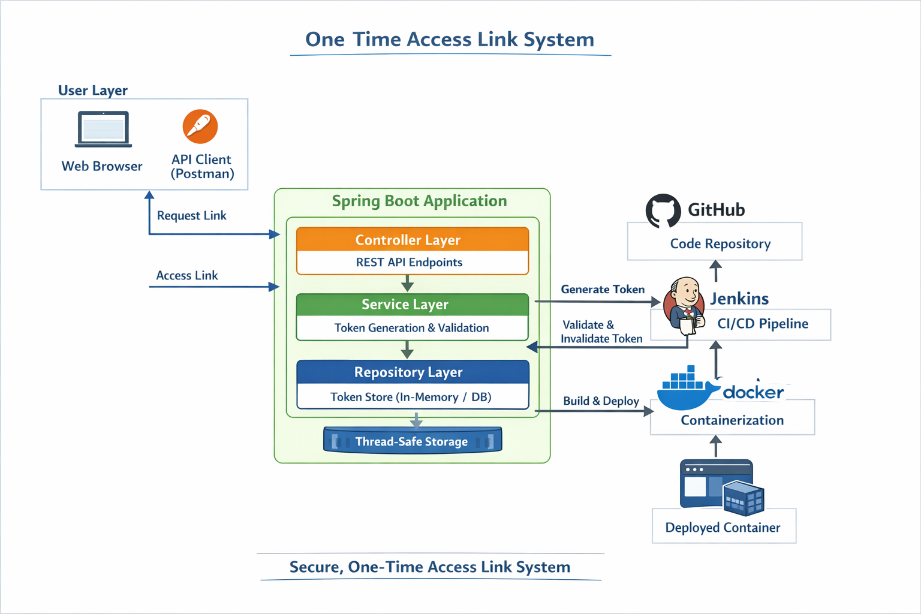
Figure 3.1: One time access link System Architecture

The Figure 3.1 shows how a developer’s code push to GitHub automatically triggers the Jenkins CI/CD pipeline. Jenkins then executes multiple stages such as code checkout, build using Maven, testing, and Docker image creation, followed by deployment of the containerized application. The Spring Boot application then handles user requests by generating secure one-time tokens, validating access requests, and invalidating tokens after their first use, ensuring strict one-time access control.
3.2 Proposed System Methodology
The system follows a layered methodology connecting four key phases:
• Development Layer : The developer writes and updates the Spring Boot application locally and pushes the code to the GitHub repository for version control
• CI/CD Layer : Jenkins detects code changes and automatically triggers the pipeline, performing stages such as checkout, build, testing, and Docker image creation
• Deployment Layer : The application is containerized using Docker and deployed as a running container, ensuring consistent execution across environments
• Application Layer : The Spring Boot application processes user requests by generating secure one-time links, validating tokens on access, and invalidating them immediately after use to prevent reuse

3.3 Summary
The system architecture is structured into four automated layers: Development, CI/CD, Deployment, and Application. Code pushed to GitHub automatically triggers a Jenkins pipeline that handles checkout, building, testing, and Docker image creation. The deployment layer ensures the application runs consistently within a Docker container across different environments. Finally, the application layer processes requests by generating secure tokens and invalidating them immediately after access to prevent reuse.

CHAPTER-4

IMPLEMENTATION DETAILS

This chapter describes the step-by-step implementation of the One Time Access Link System and its CI/CD pipeline. It covers how each component of the system was built — from the Spring Boot backend and token generation logic to REST API development, Maven configuration, Jenkins pipeline setup, and Docker deployment. The implementation follows a structured approach where each module was developed and tested individually before integrating into the complete system.

4.1 Token Generation and Access Implementation
The core functionality of the system is implemented using Spring Boot, where a secure token is generated and validated:
• A unique token is generated using UUID for each request
• The token is embedded into a URL and shared with the user
• When the link is accessed, the system validates the token
• If valid, access is granted and the token is immediately invalidated
• If the same link is used again, access is denied
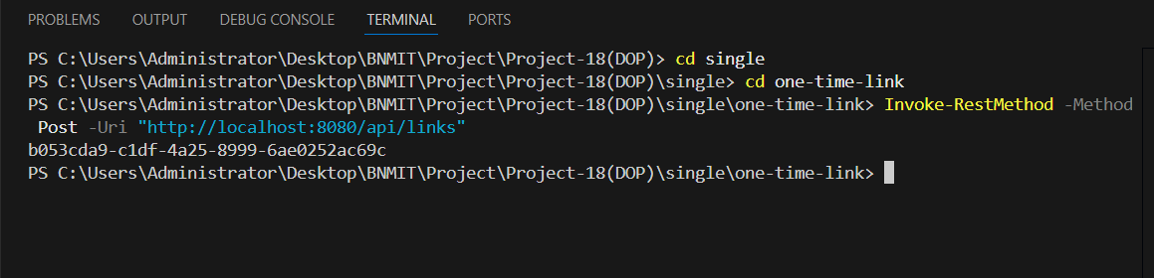
Fig 4.1: Token Generation and Validation Code
The Figure 4.1 shows the implementation of token generation using UUID and the validation logic in the Spring Boot application.

4.2 REST API Implementation
The system provides REST API endpoints for handling link generation and access:
• POST /generate-link — Generates a new one-time access link
• GET /access/{token} — Validates the token and provides access
• Proper HTTP responses are returned for invalid or reused tokens
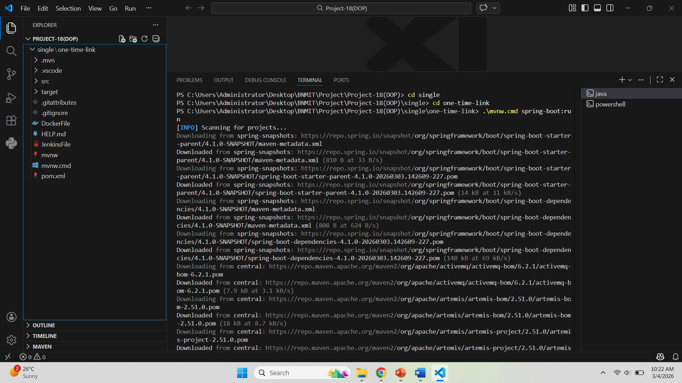
Fig 4.2: REST API Testing using Postman
The Figure 4.2 shows API testing for generating and accessing one-time links using Postman.

4.3 Maven Configuration
The project is configured using pom.xml with the following setup:
• Java version is specified for compilation
• Spring Boot dependencies are included
• Maven is used for building the project
• The application is packaged as a JAR file

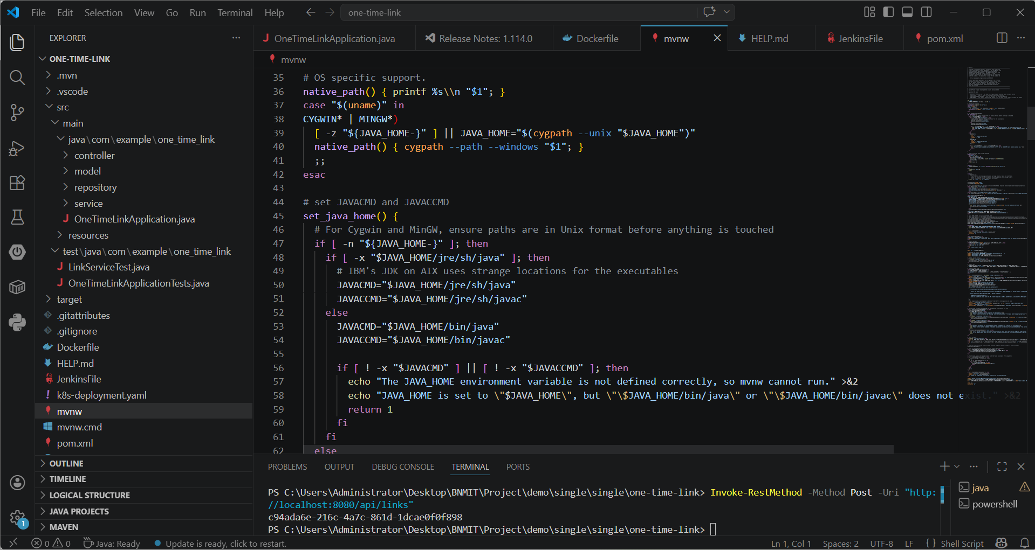
Fig 4.3: Maven Configuration (pom.xml)
The Figure 4.3 shows the pom.xml configuration used for building and packaging the application.
4.4 Token Storage Implementation
The system uses thread-safe storage to manage tokens:
• Tokens are stored using ConcurrentHashMap
• Ensures safe access in concurrent environments
• Prevents multiple usage of the same token
• A unique token is generated using UUID for each request
• The token is embedded into a URL and shared with the user
• When the link is accessed, the system validates the token
• If valid, access is granted and the token is immediately invalidated
• If the same link is used again, access is denied

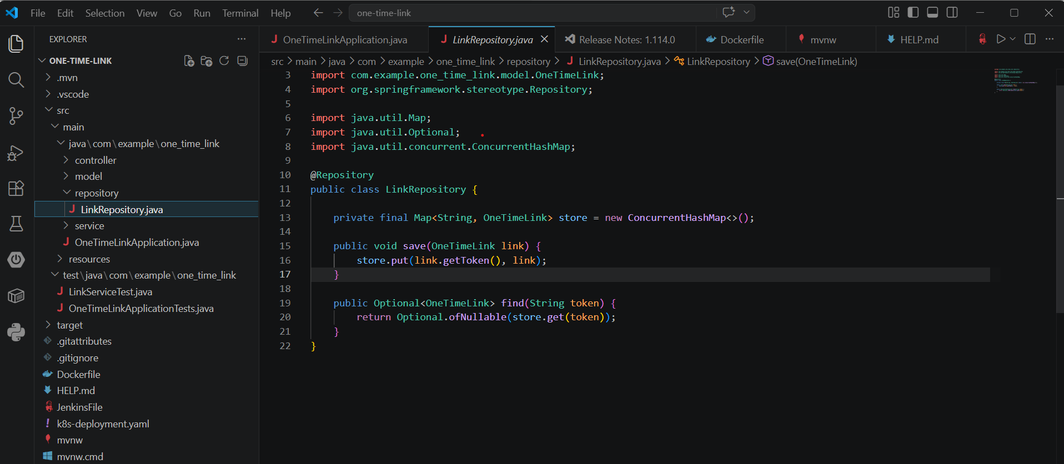
Fig 4.4: Token Storage using ConcurrentHashMap
The Figure 4.4 shows how tokens are stored and managed safely in the system.

4.5 Jenkins Pipeline Implementation
It covers how each component of the system was built — from the Spring Boot backend and token generation logic to REST API development, Maven configuration, Jenkins pipeline setup, and Docker deployment. The implementation follows a structured approach where each module was developed and tested individually before integrating into the complete systemThe Jenkins CI/CD pipeline automates the build and deployment process:
• Stage 1 — Checkout — Retrieves code from GitHub
• Stage 2 — Build — Compiles the application using Maven
• Stage 3 — Test — Executes test cases
• Stage 4 — Package — Generates the JAR file
• Stage 5 — Docker Build — Creates Docker image
• Stage 6 — Deployment — Runs the container

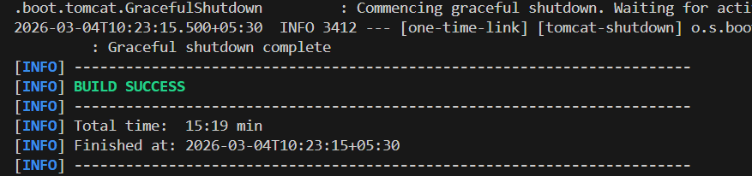
Fig 4.5: Jenkins Pipeline with All Stages
The Figure 4.5 shows the Jenkins pipeline execution with all stages.

4.6 Docker Deployment
Docker is used to containerize and deploy the application:
• Dockerfile is created for the application
• Docker image is built using the Dockerfile
• Container is created and executed
• Application runs on a specified port
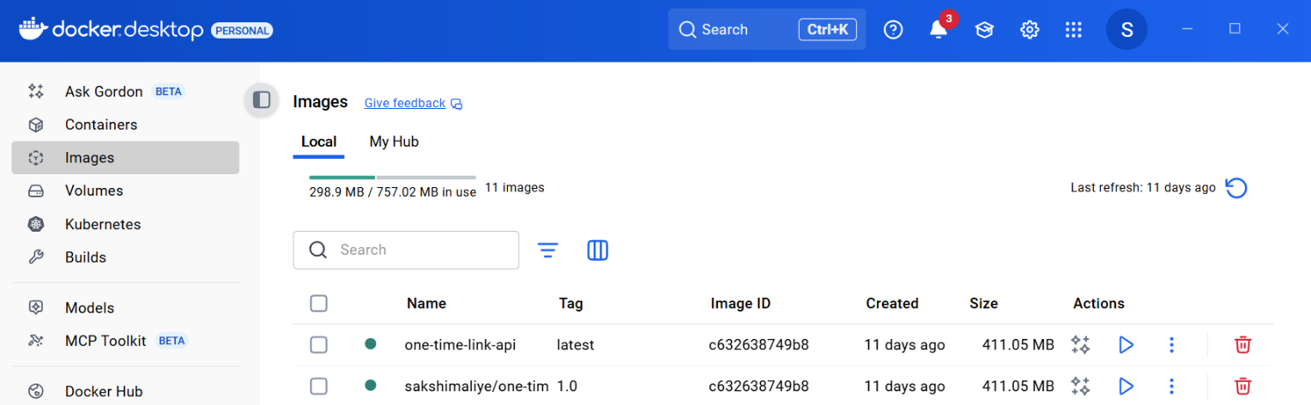

Fig 4.6: Docker Container Deployment
The Figure 4.6 shows the Docker container running the application.

4.7 Execution Flow
- User requests a one-time access link
- Token is generated using UUID

- Link is shared with the user
- User accesses the link
- Token is validated by the system
- Token is invalidated after use
- Reuse of the link is rejected

4.8 Summary
The core functionality generates unique UUID tokens embedded into URLs and validates them upon access. Token storage is managed safely in concurrent environments using Java's ConcurrentHashMap to prevent multiple usages. The Jenkins CI/CD pipeline automates the entire lifecycle through six stages: checkout, build, test, package, Docker build, and deployment. The application is containerized by creating a Docker image from a Dockerfile and executing the container on a specified port.

CHAPTER 5

RESULTS AND ANALYSIS
`
This chapter presents the results obtained from the One Time Access Link System and analyzes the system performance in terms of security, functionality, and DevOps integration. The results demonstrate successful token generation, one-time access enforcement, API functionality, and automated deployment using the Jenkins CI/CD pipeline along with Docker-based deployment.

5.1 Token Access Results
The system was tested by generating one-time access links and verifying their behavior under different conditions. Each generated link was accessed to validate whether the system correctly allows only a single use and rejects further attempts.
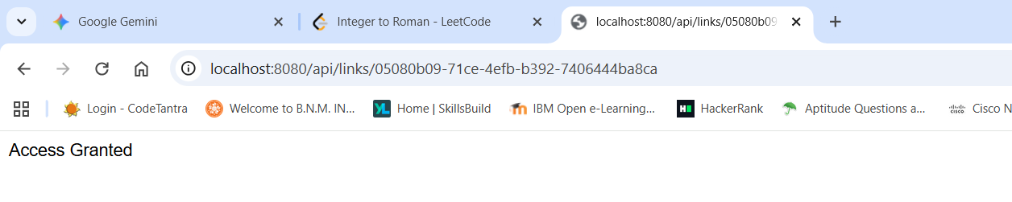

Fig 5.1: Valid Token Access Result
The Figure 5.1 illustrates the successful access of a valid one-time link, where the system grants access when the token is used for the first time.
• Link generation API successfully returns a unique token
• Access API validates tokens correctly
• Invalid or expired tokens return appropriate error responses
• Token generation is fast and secure
• One-time access enforcement works correctly
• System prevents reuse of tokens effectively
• API responses are quick and reliable
• CI/CD pipeline reduces manual effort and deployment errors

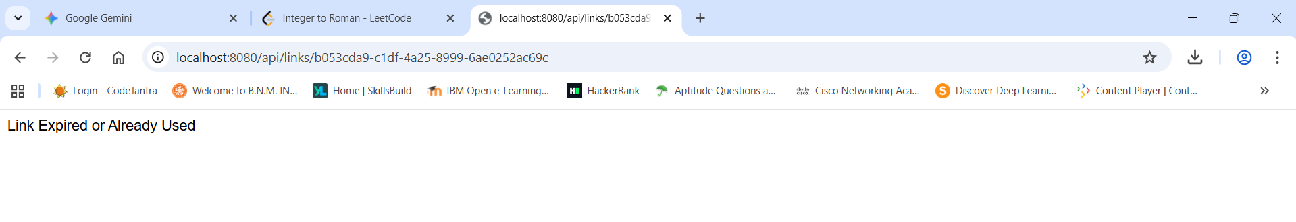
Fig 5.2: Reused Token Access Result
The Figure 5.2 illustrates the behavior when the same link is accessed again, where the system rejects the request and returns an HTTP 410 (Gone) response, confirming that the token has been invalidated after first use.

5.2 API Testing Results
The REST API endpoints were tested using Postman to verify proper functionality of link generation and access validation.
• Link generation API successfully returns a unique token
• Access API validates tokens correctly
• Invalid or expired tokens return appropriate error responses
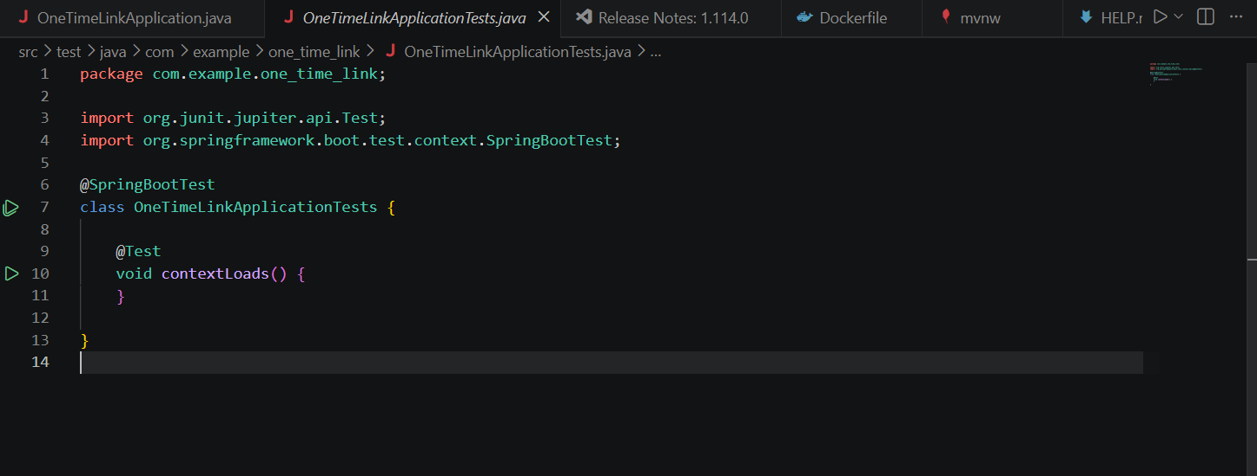
Fig 5.3: API Testing using Postman
The Figure 5.3 illustrates the API testing results, showing successful generation and validation of one-time access links.

5.3 CI/CD Pipeline Results
The Jenkins pipeline was executed successfully with all stages completing without errors. The pipeline was automatically triggered when changes were pushed to the GitHub repository, demonstrating Continuous Integration.

Fig 5.4: Jenkins Pipeline Execution
The Figure 5.4 illustrates the Jenkins pipeline with all stages such as checkout, build, test, package, and deployment completed successfully.
5.4 Docker Deployment Results
The application was successfully containerized and deployed using Docker. The container ran without any dependency or environment-related issues.


Fig 5.5: Docker Container Running Application
The Figure 5.5 illustrates the running Docker container hosting the Spring Boot application.

5.5 System Performance Analysis
The system was evaluated based on functionality and performance:

• Token generation is fast and secure
• One-time access enforcement works correctly
• System prevents reuse of tokens effectively
• API responses are quick and reliable
• CI/CD pipeline reduces manual effort and deployment errors

5.6 Advantages of the System
• Provides secure one-time access to resources
• Prevents unauthorized reuse of links
• Lightweight and efficient implementation
• Automated deployment using DevOps tools
• Easy to extend and integrate

5.7 Limitations
• Uses in-memory storage (tokens lost on restart)
• No user authentication mechanism
• Limited frontend interface
• Not deployed on cloud platform

5.8 Summary
The results confirm that the One Time Access Link System functions as intended, providing secure and reliable one-time access control. The integration of DevOps tools ensures automated deployment and efficient system management, making the solution suitable for real-world applications with further enhancements.

CHAPTER-6

CONCLUSION AND FUTURE ENHANCEMENT
This chapter summarizes the overall outcome of the One Time Access Link System project and reflects on the objectives that were achieved. It also outlines the potential future enhancements that can be made to improve the functionality, scalability, and real-world applicability of the system. The project successfully demonstrates the implementation of secure one-time access control along with modern DevOps practices, resulting in a reliable and automated application deployment process.

6.1 Conclusion
The One Time Access Link System was successfully designed, developed, and deployed as a complete backend application. All defined objectives were achieved — the system generates secure unique tokens, provides one-time access to resources, validates tokens correctly, and ensures that each token is invalidated immediately after its first use, thereby preventing unauthorized reuse and replay attacks.

The application was developed using Spring Boot and implemented as a RESTful API, ensuring efficient communication and modular design. The use of UUID-based token generation and thread-safe data structures ensures both security and reliability, even in concurrent access scenarios.

A fully automated CI/CD pipeline was implemented using Jenkins, which performs tasks such as code checkout, build, testing, and deployment. The pipeline is automatically triggered on code changes pushed to GitHub, demonstrating the principles of Continuous Integration and Continuous Deployment.

The application was containerized using Docker, ensuring consistent execution across different environments and simplifying the deployment process. Overall, the project demonstrates a complete software development lifecycle, from design and implementation to automated deployment, while focusing on security and DevOps integration.

6.2 Future Enhancements
While the current implementation meets the core requirements, the following enhancements can be considered for future development:

• Token Expiration Mechanism : In addition to one-time usage, tokens can be assigned an expiration time to automatically invalidate unused links after a specific duration
• Database Integration : Replace in-memory storage with a persistent database such as MySQL or MongoDB to retain token data even after system restart
• User Authentication : Implement authentication and authorization mechanisms to restrict access and allow user-specific link generation
• Cloud Deployment : Deploy the application on cloud platforms such as AWS, Azure, or Google Cloud for better scalability and availability
• Email Integration : Automatically send generated one-time links to users via email for real-world use cases like password reset systems
• Monitoring and Logging : Integrate tools like Prometheus and Grafana for real-time monitoring and logging of system activities
• API Security Enhancements : Implement advanced security measures such as JWT authentication, rate limiting, and HTTPS enforcement
• Microservices Architecture : Convert the application into microservices for better scalability, flexibility, and maintainability

6.3 Summary
The project successfully delivered an automated backend application that generates secure tokens and invalidates them after a single use. It demonstrated a complete software development lifecycle by integrating Spring Boot RESTful APIs with Docker and Jenkins. Future enhancements propose integrating a persistent database like MySQL or MongoDB to replace in-memory storage. Additional recommendations include implementing user authentication, email integration, and migrating the deployment to cloud platforms like AWS or Azure.

REFERENCES

[1] VMware, “Spring Boot Reference Documentation,” Spring.io, 2025. [Online]. Available: https://docs.spring.io/spring-boot/docs/current/reference/html/

[2] Oracle Corporation, “Java Platform, Standard Edition Documentation,” Oracle.com, 2025. [Online]. Available: https://docs.oracle.com/en/java/javase/17/

[3] Apache Software Foundation, “Apache Maven Project Documentation,” Maven.apache.org, 2025. [Online]. Available: https://maven.apache.org/guides/

[4] Jenkins Project, “Jenkins User Documentation,” Jenkins.io, 2025. [Online]. Available: https://www.jenkins.io/doc/

[5] Docker Inc., “Docker Documentation,” Docs.docker.com, 2025. [Online]. Available: https://docs.docker.com/

[6] GitHub Inc., “GitHub Documentation — Getting Started with Git,” Docs.github.com, 2025. [Online]. Available: https://docs.github.com/en/get-started

[7] OWASP Foundation, “OWASP Top 10 Web Application Security Risks,” OWASP.org, 2023. [Online]. Available: https://owasp.org/www-project-top-ten/

[8] Baeldung, “Guide to UUID in Java,” Baeldung.com, 2024. [Online]. Available: https://www.baeldung.com/java-uuid

